OPTIMIZATION OF THE UTILIZATION AND MANAGEMENT OF THE FAMILY MEDICINAL PLANTS (TOGA) IN KAMULAN VILLAGE

Athiqotussalma¹*, Fidian Yulianti¹, Hikma¹, Novinta Sari¹, Nurul Mufidah¹, Reza Renaldy¹, Al Mutashim Billah¹, Farrel Pasislillah Rahmadanto¹, Nugie Aditya¹, Moh. Arfin Yusrian Halida¹

¹ UIN Sunan Kalijaga, Yogyakarta
* 20101020098@student.uin-suka.ac.id

Abstract - Family Medicinal Plants (TOGA) are house plants that have medicinal properties. Family medicine garden land is basically a plot of land, either in yards, gardens or fields that are used to cultivate medicinal plants. These plants are used as medicine to meet the medicinal needs of the family. The problems that are often experienced by the community include the lack of family knowledge and public awareness about the use of TOGA and optimization of land use for family medicinal plants, the lack of TOGA books as a reference in making TOGA materials and the lack of instructions regarding the names and benefits of each TOGA. Services that have been carried out include cleaning the site, giving and planting TOGA seeds, making bamboo fences to support the TOGA plants, and caring for the plants. The stages carried out in this study were observation, planning, and implementation. In this study using descriptive qualitative method put forward by I Made Winartha. The conclusion is an increase in family knowledge and skills in utilizing family medicinal plants, the availability of 11 TOGA seeds for residents, namely ginger, turmeric, galangal, aromatic ginger, Dracaena trifasciata, and butterfly pea flower. In maximizing the use of Asman Toga, the authors added several new plant seeds such as tomato, chili, eggplant, strawberry and papaya seeds.

Keywords: Optimization, Land Use, Family Medicinal Plants

- INTRODUCTION
Public health cannot be separated from the way of life of the community which leads to the maintenance of health conditions, change and productivity through promotive and preventive efforts(Wantini et al., 2021).Increasing people's awareness, motivation and ability to live a healthy lifestyle will accelerate the achievement of optimal health status. So far, Indonesia has experience in efforts to maintain and maintain its health independently by utilizing knowledge and skills passed down from generation to generation in daily life in the form of herbal drinks, concoctions that are applied topically, inhaled and combined with massage (Puspitasari et al., 2021)
According to 2018 basic health research data, it is known that households in Indonesia still use traditional health services (Yankestrad) with a percentage of 12.9% for households that make independent efforts in treatment and 55.7% for households that do not use Yankestrad. The types of traditional health efforts that are most frequently utilized are manual skills (65.3%), ready-made potions (48%), homemade potions (31.8%), energy skills (2.1%), thought processing skills, (1.9%)(Wantini et al., 2021). This shows that In Indonesia, the use of traditional medicine is still trusted by some groups to treat various diseases.
Traditional medicine is a combination of herbal ingredients containing plant extracts, animal products, minerals, ingredients that are mixed and prepared for consumption and are believed by generations to cure a disease. Traditional medicine is also called phytotherapy, because the ingredients used come from natural ingredients (Food and Drug Supervisory Agency Regulations, 2019). Herbs in everyday life we ​​often know as spices. Herbs can play a role in first aid for health problems and are proven to be effective in curing various kinds of diseases, even diseases that are almost incurable, although there is still a chance that they can be cured using herbal ingredients. This is because herbal treatment is easier for the body to accept so healing can be faster (Harefa, 2020).
Utilizing yard land in rural and urban areas to plant medicinal plants is one effort that can be achieved and is highly recommended to support government steps in maintaining public health. This needs to be done not only by relying on government efforts, but also by active community participation, starting from the smallest line forming society, namely the family (Bulkaini et al., 2021). One of the benefits that can be obtained from utilizing empty land or village parks is fulfilling the community's needs for traditional medicines (Sugito, Susilowati, 2017). One of the medicinal plants that can be cultivated is Family Medicinal Plants (TOGA) or what used to be called "Living Pharmacy"(Puspitasari et al., 2021).
TOGA is a plant whose maintenance is natural and easy to plant or cultivate around the yard or yard which has medical properties, namely to help cure diseases (Mukharromah, 2022). The presence of medicinal plants in the home environment is very important, especially for families who do not have easy access to health services such as clinics, health centers or hospitals (Puspitasari et al., 2021). This is because there are still many people who believe that herbal medicines have a better healing effect than synthetic drugs (Parawansah et al., 2020). Benefit TOGA for independent health includes; a) Increasing the body's resistance so that it is not susceptible to disease, b) Preventing disease, health risks and the after-effects of certain diseases, c) Overcoming minor health complaints and first aid efforts for an illness (Akhmad et al., 2022).
The Government of Indonesia supports the use of TOGA to improve the health of the Indonesian people, through Regulation of the Minister of Health Number 9 of 2016 concerning efforts to develop health through self-care (Asman) using TOGA and skills. Asman Toga is an effort to maintain and improve health as well as prevent and overcome minor health problems by individuals, families and communities by utilizing TOGA and skills in using it (Ariastuti et al., 2019). Currently, a healthy lifestyle that is environmentally friendly has become a new trend, leaving old lifestyles that use unnatural chemicals. A healthy lifestyle has now become institutionalized internationally, which implies a guarantee of food and medicine products that are safe to consume, have high nutritional content and are environmentally friendly (Rasmikayati et al., 2021).
Kamulan Village, Durenan District, Trenggalek Regency is one of the villages that has mobilized its community to create a garden in the village hall called "ASMAN TOGA" to be used as a place to plant medicinal plants (TOGA). However, this program has not been able to run completely perfectly because it is still hampered by several factors, such as limited public knowledge of the use of medicinal plants, a lack of available types of medicinal plants, and parks that are poorly maintained so that many plants die and are not well looked after.

- METHOD
Implementation of optimizing the utilization and management of family medicinal plant gardens (TOGA) is carried out in Kamulan Village, Durenan District, Trenggalek Regency. Researchers conduct site surveys or direct visits. Direct visits aim to observe the condition of village problems by conducting interviews as well as documentation (Rasmikayati et al., 2021). Kamulan Village Hall previously had land for the use and management of family medicinal plants (TOGA). However, the utilization and management of Asman Toga at the Kamulan Village Hall has not been carried out optimally.
Seeing the condition of the Asman Toga at the Kamulan Village Hall, researchers were moved to optimize the use and management of the Asman Toga. The stages carried out in the form of observation, planning, and implementation. The aim of the observation stage is description, which gives rise to theories and hypotheses(Hasanah, 2017). At the planning stage, tools and materials are prepared as well as the planting media that will be used. Then at the implementation stage, the optimization process is carried out.
The method used in this research is descriptive qualitative method. According to I Made Winartha (in Lindawati & Hendri, 2016) qualitative descriptive method is analyzing, describing, and summarizing various conditions, situations from various data collected in the form of interviews or observations regarding the problems studied that occur in the field. A part from that, according to Sukmadinata (in Tia Perdani 2020) descriptive research is "the lowest research among other research" because this research aims to provide an overview of natural phenomena or the results of human engineering. In conducting the research, it does not provide treatment or manipulate the independent variables. But it gives an idea of ​​the condition as it is (Perdani, 2020). In this research, the description of conditions in the field was carried out using a development strategy as an optimization effort.

- RESULTS AND DISCUSSION
Location Survey
A location survey or field survey is a very important initial stage in planning an activity, especially when determining the right location that will be used as a place to plant medicinal plants to make it a living pharmacy.(bagi et al., 2022). A location survey was carried out by researchers to observe and determine the initial conditions of the Asman Toga park located at the Kamulan Village Hall in the picture below:
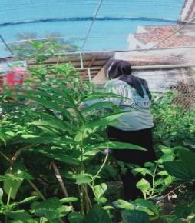
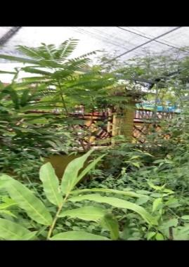
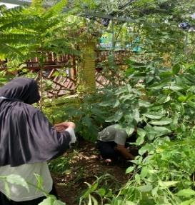

Figure 1. Asman Toga location survey

Cleaning the Asman Toga Location
After conducting a survey at Asman Toga Park, he found that the condition of the park was very neglected, this was evident from the large number of weeds growing and the layout of the plants which seemed untidy. So the researchers next took action to clean up the park. Cleaning is done by pulling out weeds around the medicinal plants, and also cleaning up rubbish around the garden.
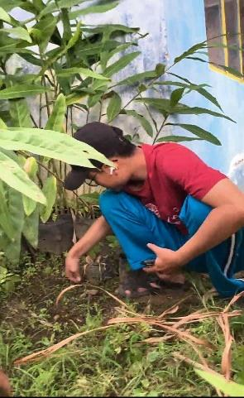
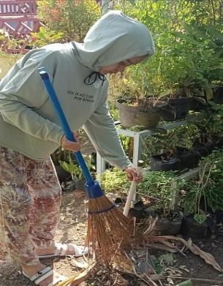
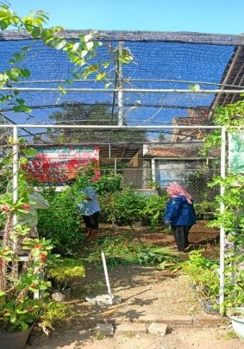

Figure 2. Cleaning the Asman Toga Park

Selection of seeds to be planted
Previously, in Asman Toga, there were only medicinal plants such as ginger, turmeric, galangal, aromatic ginger, Dracaena trifasciata, and butterfly pea flowers. In maximizing the use of Asman Toga, the author added several new plant seeds such as tomato, chili, eggplant, strawberry and papaya seeds. With the addition of this new plant, the authors hope that it will be more useful for the surrounding community in meeting their daily needs.

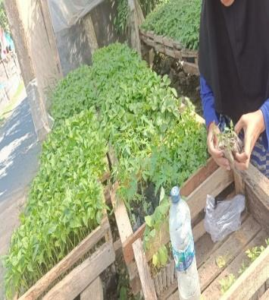
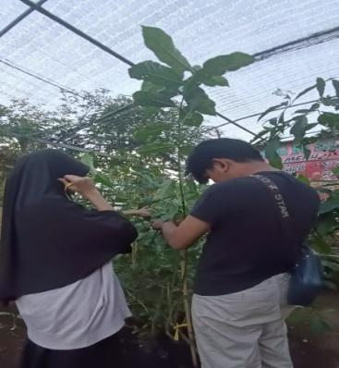

Figure 3. Selecting plant seeds

Soil Media Preparation
Planting media is an important factor that determines the success or failure of planting various types of plants. Soil as a planting medium is determined by its structure and texture. Soil that has a good texture will influence the rate of infiltration, nutrient leaching, water movement, root development and penetration. Poor soil structure is corrected by adding organic matter elements to increase the stability of soil aggregates and maintain soil aeration. Well-aerated soil can increase root development and increase water absorption due to increased available oxygen(Nor et al., 2023). Before planting, the things that need to be prepared are soil that is loose and fertile, two pots and three polybags.
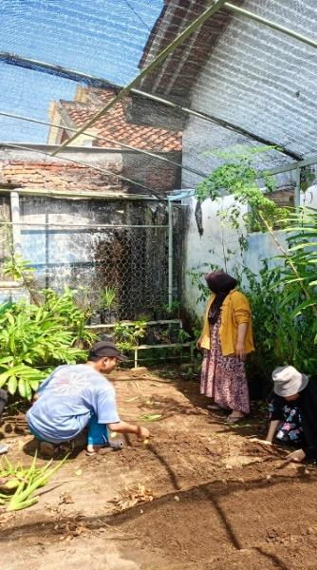
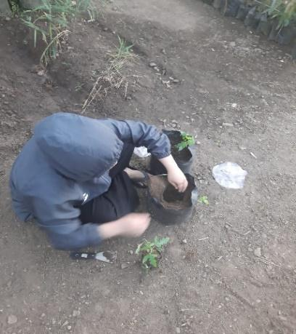

Figure 4. Preparation of soil media

Planting Seeds
After loosening the soil and filling the polybags with soil, proceed with planting. Additional types of vegetable seeds planted are eggplant, chili and tomato seeds. Apart from vegetables, there are various types of medicines such as turmeric, galangal, ginger and galangal as well as fruit seeds, namely strawberries and papaya. Planting is done by making a hole in the surface of the soil and then covering it again with soil on top
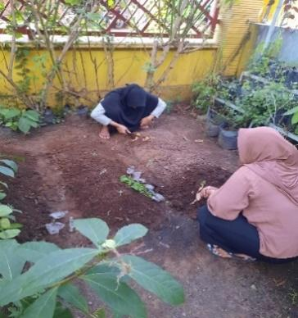
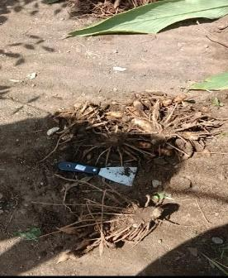

Figure 5. Planting crops
Making Bamboo Fence
Asman Toga Park previously had a poor and neat arrangement so the author decided to make a fence which aims to help the creeping plants have a place to grow and protect the plants from animals and also as a barrier between the plants so that they are not too close so that the plants have room to grow. The function of making a fence in Asman Toga. Following are the steps for making a bamboo fence.
- Preparing bamboo
- Measure and cut the bamboo according to the required size, which is 1.5 m. Carefully measure and cut the bamboo to fit what is needed
- Tidy up the bamboo pieces to make it easier for the next step. S looks neat.
- Bamboo paint. Bamboo painting is done to make it more durable and look attractive
- Combine bamboo. Bamboo is joined by using nails with equal spacing between the bamboos.
- Install a bamboo fence. After the bamboo is combined, proceed to the final stage, namely installing a fence around the plants.

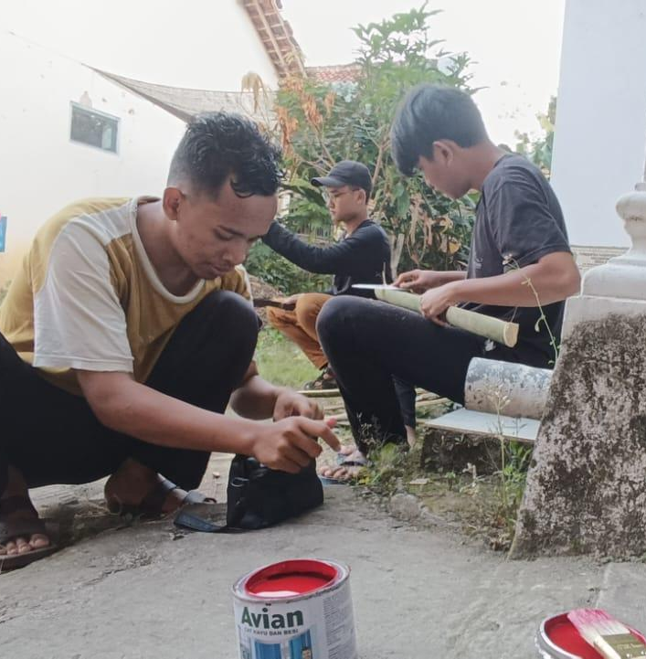
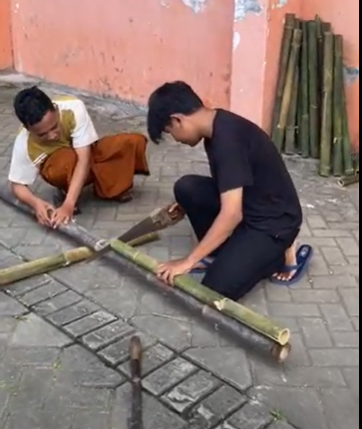

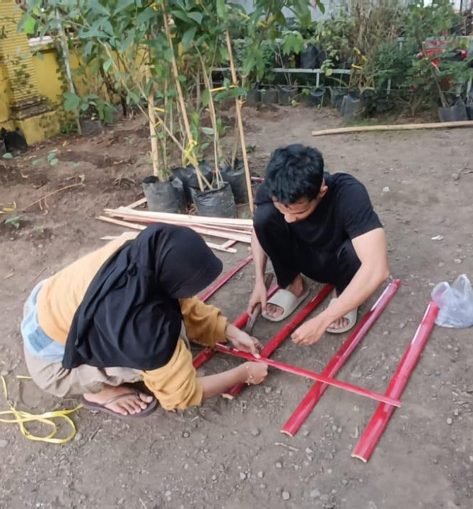
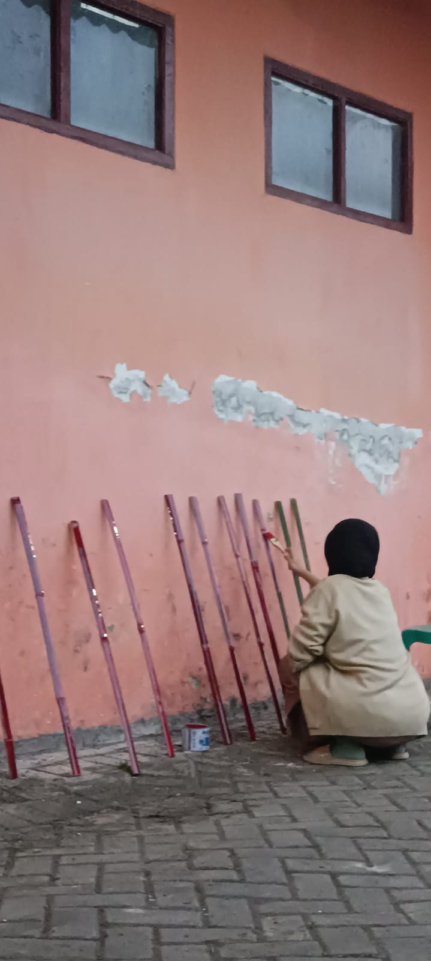

Figure 6. Making a bamboo fence
Plant Care
The final stage is caring for the plants by watering the plants regularly every day. Watering can maintain and care for plants so they grow well. The need for sufficient water is very important for plants. So it is necessary to monitor the watering process to ensure that watering continues to run optimally (Mukharromah, 2022).
Factors that influence plant growth and yield include (Nor et al., 2023):
- Plant material factor groups (heredity, purity and germination)
- Essential factor group (light, water, nutrients)
- Group of climatic factors (rain, air temperature, air humidity, wind, light and day length)
- Group of nuisance factors (pests, diseases and weeds)
At Asman Toga Park, watering is done once a day, namely in the morning, by the Kamulan Village Hall gardener. So the plants will not experience drought due to lack of water.

- CONCLUSION
Indonesia has very abundant biodiversity, one of which is the family of medicinal plants (TOGA). TOGA is a plant that has properties in treating and preventing various types of diseases. From the activities carried out by the KKN 111 group in Kamulan Village, Durenan District, Trenggalek Regency, it can run well and smoothly. Apart from that, improvements can be seen in the Asman Toga land in the Kamulan Village Hall, such as rearranging the Asman Toga land in the Kamulan Village Hall which is still less than optimal, adding several nutritious plant seeds and building fences in the Asman Toga to prevent attacks from animals. The implementation of TOGA cultivation activities in Kamulan Village has not been able to reach the production stage so that it can be used economically.
This activity can be carried out in various places in the village. There are several aspects of obstacles that need attention. In the aspect of harvest constraints, the unscheduled and non-routine harvesting process is the main obstacle. On the land aspect, Kamulan Village, Durenan District, Trenggalek Regency has a lot of yard land to be used as TOGA land, however, the use of yard land for TOGA is considered not optimal for residents. the village, because all this time the people's yards have not been used for anything of value economy. Further service can be carried out, namely by holding TOGA compounding training so that it has economic value.

REFERENCE
Akhmad, I., Kusumah, A., Tachta Hinggo, H., Zaki, H., Hardilawati, WL, Ramadhan, RR, Sulistyandari, Abunawas, Hastuti, D., & Alif Ramadhan, S. (2022). Concern for a Healthy Environment Through Economically Valued Toga Planting Activities in Artificial Villages I. ABDIMAS EKODIKSOSIORA: Journal of Economic, Educational and Social Humanities Community Service (e-ISSN: 2809-3917), 2(2), 168–171. https://doi.org/10.37859/abdimasekodiksosiora.v2i2.4435
Ariastuti, R., Dyah Herawati, V., Pharmacy Studies, P., Health Technology Science, F., Sahid Surakarta, U., & Improving Community Health in Banyudono District, U. (2019). Utilization of Family Medicinal Plants (TOGA) in Efforts to Improve Community Health in Banyudono District, Boyolali Asuhan Mandiri Family Medicinal Plants (TOGA) in. Journal of Pharmaceutical and Medicinal Sciences, 4(2), 30–37.
Bagi, K., Desa, M., Srengat, K., Blitar, K., Dwi, A., Hamidah, S., Oktavia, AW, Puspitasari, A., Prastiwi, E., & Marselina, AP (2022 ). e-ISSN: 2808-4152 p-ISSN: 2808-666X. 2(1), 56–64.
Bulkaini, B., Akbar, MA, Maolani, A., Pratama, S., Zaharani, LN, Apriana, E., Handayani, S., Akbar, W., & Handayani, F. (2021). Optimizing the Utilization of Vacant Land Based on Vegetables and Living Pharmacy in Sigar Penjalin Village, Tanjung District, North Lombok Regency. Journal of Service Master of Science Education, 4(2), 2–5. https://doi.org/10.29303/jpmpi.v4i2.706
Harefa, D. (2020). Utilization of Plant Products as Family Medicinal Plants (TOGA). Madani : Indonesian Journal of Civil Society, 2(2), 28–36. https://doi.org/10.35970/madani.v2i2.233
Hasanah, H. (2017). OBSERVATION TECHNIQUES (An Alternative Method of Gathering Qualitative Data in the Social Sciences). At-Taqaddum, 8(1), 21. https://doi.org/10.21580/at.v8i1.1163
Mukharromah, N.L. (2022). Education, Introduction, and Planting of Toga as an Effort to Increase Awareness of Healthy Living of Students of Sdn Ketangirejo 1 Pasuruan. Journal of Community Service, 2(2), 1–23.
Nor, I., Latifah, N., Zamzani, I., Sa'adah, H., Fatmawati, E., Nurhanifah, D., & Rahma, A. (2023). Utilization and Productivity Increase of Family Medicinal Plants (Toga) for Traditional Herbal Drinks as Immunostimulants. SELAPARANG: Journal of Progressive Community Service, 7(1), 190. https://doi.org/10.31764/jpmb.v7i1.12281
Parawansah, P., Esso, A., & Saida, S. (2020). Socialization of the Use of Family Medicinal Plants as an Effort to Increase the Body's Immunity in the Midst of a Pandemic in Kendari City. Journal of Community Engagement in Health, 3(2), 2018–2021.
Food and Drug Supervisory Agency Regulations. (2019). BPOM Regulation Number 32 of 2019 concerning Requirements for the Safety and Quality of Traditional Medicines. Bpom Ri, 11, 1–16.
Perdani, T. (2020). 346341073. 26–29.
Puspitasari, I., Sari, GNF, & Indrayati, A. (2021). Utilization of Family Medicinal Plants (TOGA) as an Alternative to Self-Medication. LPM Newsletter, 24(3), 456–465. https://doi.org/10.23917/warta.v24i3.11111
Rasmikayati, E., Putra, AE, & Saefudin, BR (2021). DESCRIPTION OF TOGA CULTIVATION ACTIVITIES BASED ON URBAN FARMING AND ASPECTS OF CONSTRAINTS FACED: A CASE OF TOGA TURMERIC IN RANCABOLANG VILLAGE, GEDEBAGE DISTRICT, BANDUNG CITY DESCRIPTION OF TOGA CULTIVATION ACTIVITIES BASED ON URBAN FARMING AND CONSTRAI. 7(1), 734–746.
Sugito, Susilowati, MAK (2017). STRATEGY FOR UTILIZING GARDEN LAND FOR CULTIVATION OF FAMILY MEDICINAL PLANTS (TOGA) Environmental Engineering Study Program; Faculty of Civil Engineering and Planning (FTSP) Family Welfare Education Study Program; Faculty of Teacher Training and Education Un. Penamas Adi Buana, 02(2), 1–8. http://jurnal.unipasby.ac.id/index.php/penamas/article/view/965
Wantini, NA, Maydianasari, L., Setyaningrum, SD, & Christi, I. (2021). Effectiveness of Health Education Utilization of Family Medicine Garden (TOGA) as Traditional Medicine Effectiveness of Health Education Utilization of Family Medicine Garden (FMG) as Traditional Medicine The Indonesian government supports the use of TOGA un. UNIMUS National Seminar Proceedings, 4, 2553–2564. https://prosiding.unimus.ac.id/index.php/semnas

