CONFERENCE PAPER • KICE 2026 • YOGYAKARTA, INDONESIA
Culture-Based Materials in English Language Teaching: A Systematic Literature Review on Language Learning and Cultural Awareness
Ni Made Alit Juliawati
English Language Education, Post Graduate Program, Universitas Pendidikan Ganesha, Singaraja, Indonesia
Email: nijuliawati37@guru.smp.belajar.id
Proceedings of the Kalijaga International Conference on Education 2026
Abstract. Culture-based materials are increasingly being recognized as key tools in the field of English Language Teaching (ELT) as they integrate language learning with learners’ cultural backgrounds. Despite this, existing research on these resources remains scattered across educational contexts, instructional media, and learning outcomes, so it is challenging to glean a complete understanding of their role in language learning and cultural awareness. This study therefore sought to synthesize recent literature on the use of culture-based materials in ELT in the form of a Systematic Literature Review (SLR). The review followed the PRISMA 2020 guidelines. Articles were retrieved from Google Scholar, Scopus, ScienceDirect, and SINTA- indexed journals with the support of the Publish or Perish application. After the identification, screening, eligibility, and inclusion processes, 14 studies published between 2021 and 2025 were selected for thematic synthesis. The findings reveal five major themes: contributions to language learning, learner motivation and engagement, cultural awareness and character. All of these studies confirm that culture-based materials have benefits to language learning outcomes (e.g., enhanced reading comprehension, stronger vocabulary and contextual language use, more favorable students' motivation and willingness to engage in class and foster self-confidence in language teaching). They also reinforce cultural awareness, cultural identity, and character values including responsibility, tolerance, empathy, and respect for diversity. In addition, the increasing use of digital culture-based learning media indicates the growing integration of technology into culturally responsive ELT. However, the existing studies are predominantly focused on reading instruction, material development and Indonesian educational settings and thus there is still much work to be done for productive language skills, intercultural communicative competence and longitudinal learning outcomes as well as emerging technologies (artificial intelligence) in relation to productive learning. This review provides an in-depth review of contemporary study trends and some practical implications for teachers, curriculum developers, and researchers to design culturally responsive English language learning materials.
Keywords: cultural awareness; culture-based materials; English Language Teaching; language learning.
Abbreviations: 1. EFL (English as Foreign Language), 2. ELT (English Language Teaching), 3. PRISMA (Preferred Reporting Items for Systematic Reviews and Meta-Analyses)
INTRODUCTION
English is increasingly the language of all people, not only for educational purposes but also for global communication, business, technology, and cultural exchange. English learning has therefore shifted from mastering grammar and vocabulary to the creation of communicative competence in cross-cultural situations among learners. Language cannot be divorced from culture here, as language is the expression and reflection of the beliefs, values, identities, and social practices of its speakers. Hence, English Language Teaching (ELT) should not only prepare learners to acquire a fluent language but also promote their understanding of different cultures. Moreover, incorporating cultural factors in the learning of language helps them communicate better and recognize their cultures, as well as those of others.
Still, as an expectation, although in many forms ELT materials have yet to adopt the localized cultural context as the basis of their focus, they still are influenced by Western or native speaker cultures and do not allow for much attention to learners' local cultures. Most of the cultural representation in the ELT textbooks remains unbalanced and tends to favour some cultures over local ones [7]. As such, learners are frequently exposed to information that is not embedded in their social and cultural context. This is a way of teaching and learning, which makes learning less connected with who those students are. Therefore, learning English may become less meaningful for students since they have fewer opportunities to explore and communicate their own culture through English.
To overcome the potential threat of such an issue, many researchers have encouraged the incorporation of culture-based elements in ELT. These resources bring to bear on ELT elements of local culture, folklore, history, values and community, and wisdom, providing a “local, human and context” into English instruction. Cultural tools help students to be fluent learners of English in the authentic content that they encounter in society and also develop a better appreciation of the local culture. Previous research also supported the theory that adding local culture to ELT leads to meaningful learning, enhances language skills and character development [10], [16]. As a result, culture-based materials constitute an effective way to develop culturally responsive English language practices.
According to previous empirical studies, research has been very beneficial in the impact that culture- based materials have on learning English. These materials have been proved across various educational contexts to enhance aspects such as the learners’ reading comprehension, listening skills, their language achievement, motivation, and communicative competence [1], [2], [8], [10], [11]. Culture-based contents not only serve as a contribution to language learning, but also promote a sense of culture, cultural identity and good character values (e.g. responsibility, tolerance and respect for local wisdom [3], [4], [14], [16]). These findings indicate that integrating local culture into ELT promotes students’ linguistic and cultural and personal development and growth.
While the positive findings in some of the previous literature have already been promising, the evidence is spread among educational levels, language abilities, instructional media, and research contexts. Most studies evaluate the efficacy of individual instructional materials, while fewer attempt to synthesize the overall body of evidence. As such, it remains to be understood the overall contribution of culture-based materials to language learning and cultural awareness, publication trends, methodological characteristics, and dominant research themes. It is a challenging task for researchers, educators, curriculum developers, and academic researchers to evaluate current research in this area and prioritize future investigations without a comprehensive synthesis.
This study addresses this gap and undertakes a Systematic Literature Review (SLR) to compile empirical evidence available about culture-based materials in English Language Teaching. This review provides a broader synthesis of recent research conducted in different educational contexts. This review maps publication trends, methodological approaches, research focuses, and future research directions in addition to examining the contributions of culture-based materials to language learning and cultural awareness. As a result, it helps us to clarify and provide a more complete view of the development of culture-based materials in ELT, noting which aspects need more research..
Accordingly, this study, entitled "Culture-Based Materials in English Language Teaching: A Systematic Literature Review on Language Learning and Cultural Awareness," aims to (1) examine research trends on culture-based materials in ELT, (2) synthesize evidence regarding their contributions to language learning, (3) analyze their role in promoting learners' cultural awareness, and (4) identify research gaps and propose directions for future research. Such findings of the review will help build a theoretical foundation for culturally responsive English language teaching with practical implications for educators, curriculum developers, and researchers involved in creating and implementing culture-based English language learning materials.
METHODS
Study area
The present study used a systematic literature review (SLR) to investigate culture-based materials and their applications in ELT. The focus areas for this research are the role of culture-based materials in language learning and cultural awareness in ELT. Although the current literature was not collected from a particular geographical region through survey data, this review examined published studies in various educational settings. Specifically, the review limited the search to journal articles published from 2021 to 2025, allowing the study to capture recent developments in incorporating local culture into English language teaching. The articles for this study were retrieved from four academic databases: Google Scholar, Scopus, ScienceDirect, and SINTA-indexed journals, as these databases provide broad coverage of international and national research related to ELT.
Procedures
The review procedure followed the Preferred Reporting Items for Systematic Reviews and Meta- Analyses (PRISMA) 2020 guidelines to ensure a transparent and systematic article selection process [13]. The procedure consisted of four stages: identification, screening, eligibility assessment, and inclusion.
During the identification stage, relevant articles were retrieved from Google Scholar, Scopus, ScienceDirect, and SINTA-indexed journals. The search was supported by Publish or Perish software, which facilitated literature retrieval and citation management across multiple academic databases [12]. The use of Publish or Perish for systematic literature retrieval has also been documented in review methodology [15].
The search employed combinations of the following keywords: culture-based materials, local culture in ELT, cultural content in English teaching, local wisdom in EFL, culture and language learning, and cultural awareness in ELT. Boolean operators (AND and OR) were used to refine the search results and improve the relevance of retrieved articles.
To ensure consistency, the retrieved articles had to satisfy the following inclusion criteria: (1) published in peer-reviewed journals between 2021 and 2025; (2) written in English or Indonesian; (3) focused on culture-based materials in English Language Teaching; and (4) reported empirical research findings. Articles were excluded if they were conference proceedings, books, theses, dissertations, review articles, or studies unrelated to ELT or culture-based materials.
The initial search identified 148 articles. After removing 32 duplicate articles, 116 articles were retained for title and abstract screening. At this point, 71 articles were eliminated for failing to fit the inclusion criteria. Full-text analyses were carried out on the remaining 45 articles, which led to the exclusion of 30 additional articles because of inadequate methodological details, missing results, publication outside of the period defined for the investigation, or lack of relevance. Finally, 14 articles were included in the qualitative synthesis. The detailed article selection process is presented in Figure 1.
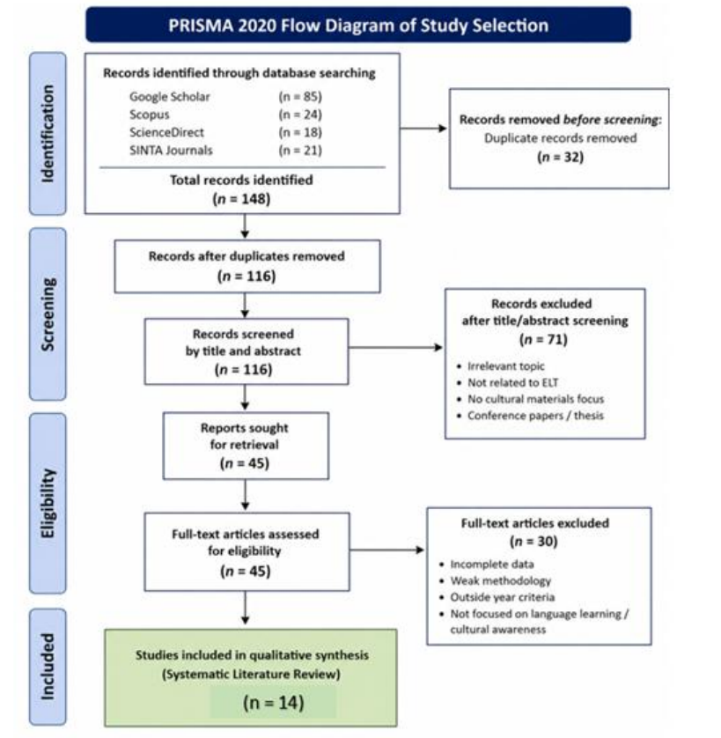
Figure 1. PRISMA 2020 Flow Diagram of Study Selection
The inclusion and exclusion criteria used in this study are presented in Table 1 below.
Table 1. The inclusion and exclusion criteria
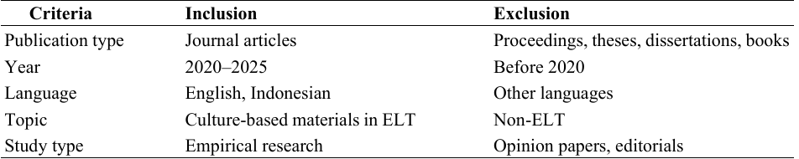
Data Analysis
The selected articles were analyzed using a thematic synthesis approach. First, relevant information was extracted from each article, including publication year, country, research design, participants, instructional materials, language skills, cultural aspects, and key findings. Next, the extracted data were organized into thematic categories to identify recurring patterns across the studies. Finally, the synthesized findings were interpreted to answer the research objectives by describing research trends, the contributions of culture-based materials to language learning and cultural awareness, and potential directions for future research.
RESULTS AND DISCUSSION
Characteristics of the Reviewed Studies Following the PRISMA 2020 article selection process, 14 studies met the inclusion criteria and were included in this systematic literature review. The selected studies were published between 2021 and 2025, reflecting increasing research interest in integrating culture-based materials into English Language Teaching (ELT). As shown in Table 2, the studies employed diverse research designs, including Research and Development (R&D), experimental, qualitative, case study, literature review, and Systematic Literature Review (SLR). This methodological diversity indicates that culture-based materials have been investigated from multiple perspectives, including language learning, instructional material development, educational technology, character education, and cultural representation. Most of the reviewed studies were conducted in Indonesia, with participants ranging from elementary school to university students. The culture-based materials examined included reading texts, storybooks, short stories, digital storybooks, digital comics, locally contextualized teaching materials, and local wisdom-based learning resources. Overall, the reviewed studies demonstrate a growing emphasis on integrating local culture into ELT to enhance language learning while promoting learners' cultural awareness and identity.
Table 2. Characteristics of Studies Included in the Systematic Literature Review
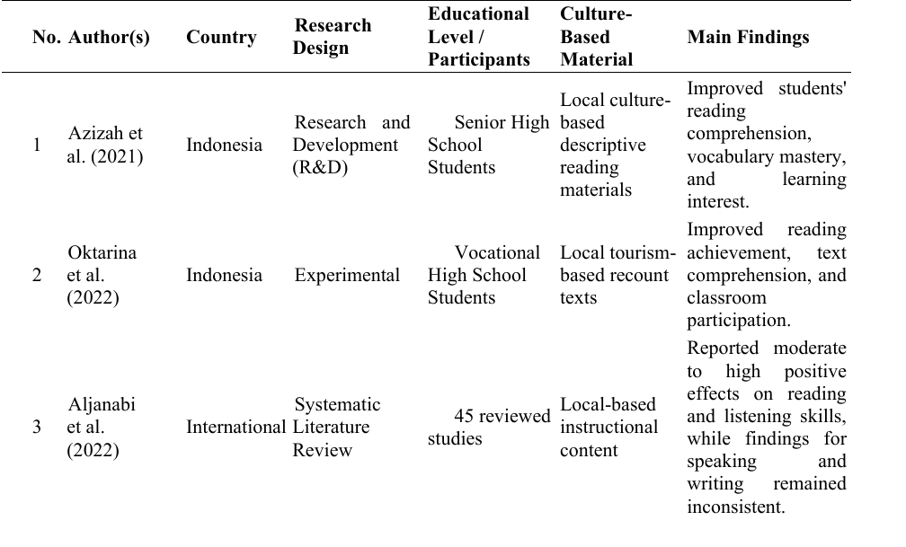
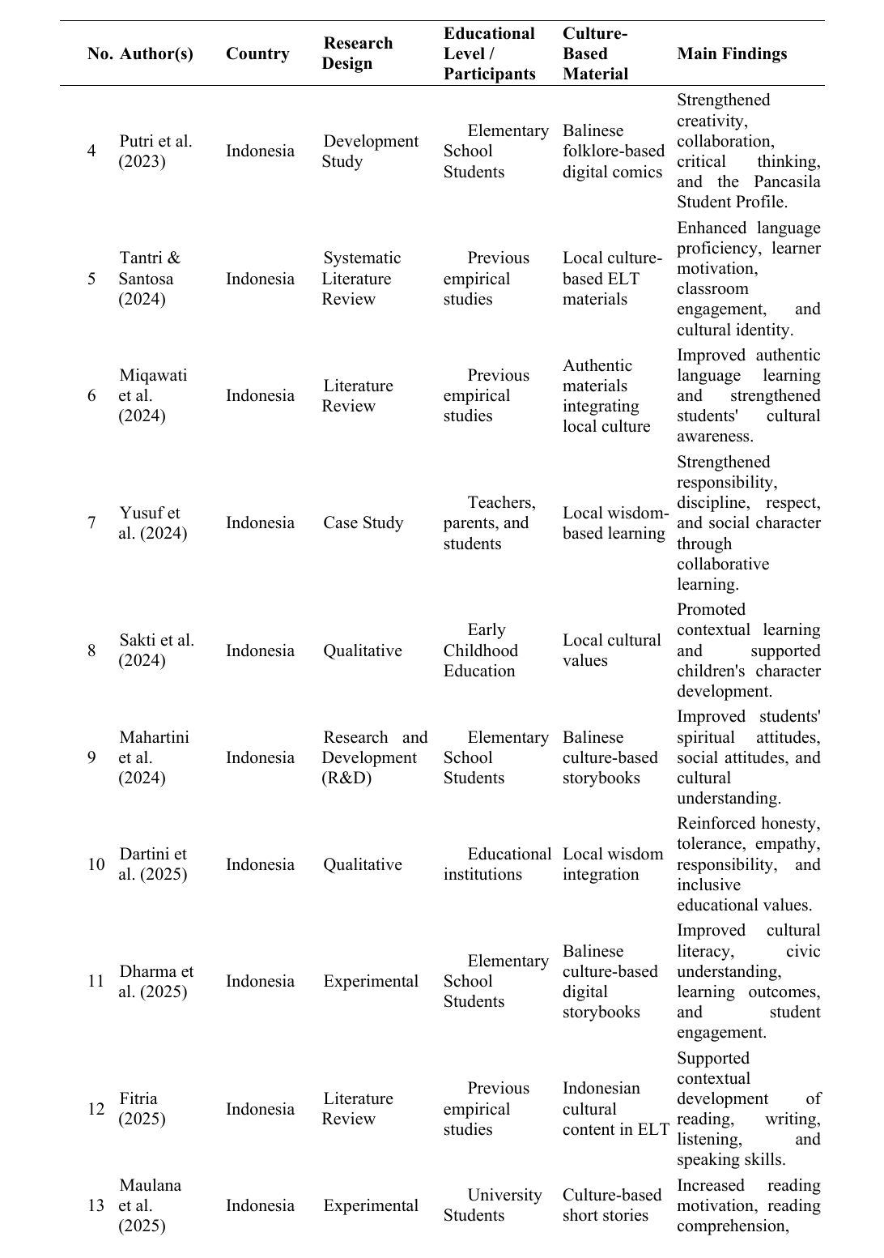
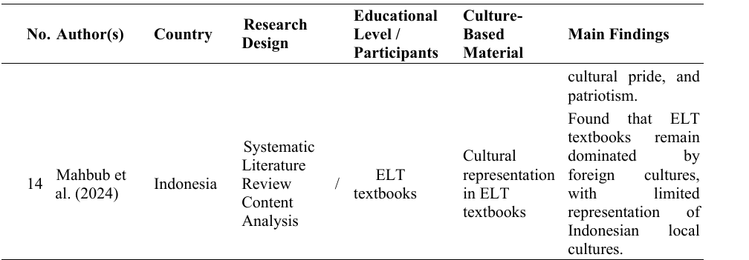
Based on the synthesis of the reviewed studies, five major themes emerged: (1) contributions to language learning, (2) learner motivation and engagement, (3) cultural awareness and character development, (4) development of culture-based instructional materials and digital media, and (5) current issues and future research directions.
Contributions to Language Learning
The studies reviewed showed that the literature strongly confirms that culture-based materials have positive effects on English language learners’ achievement. The majority of the studies described improvements in reading comprehension, vocabulary acquisition, language achievement, and communicative competence, all being significant after introducing local cultural content in classroom instruction [4], [5], [6], [12]. Learning materials that reflected familiar cultural experiences and local contexts had the tendency to allow students to comprehend English texts better.
Some research also found that culture-based materials aid in the development of language beyond reading skills and contribute to broader language development. The systematic literature search carried out by Aljanabi et al. found moderate-to-high impact on reading and listening comprehension, whereas evidence regarding speaking and writing remained less consistent [6]. Similarly, Fitria argued that the incorporation of Indonesian culture into ELT provides rich experiences for the development of all four language skills in contextualized learning environments [12]. Taken together, the results indicate that culture-based resources can enhance language learning by integrating linguistic understandings with learners’ own cultural experiences [2], [4], [5], [6], [12].
Learner Motivation and Engagement
Another key finding was about students’ motivation and involvement in English learning. The majority of the reviewed studies found that culture-based materials enhanced students' learning interest as the instructional material reflected their own cultural backgrounds and everyday experiences [2], [5], [7], [10]. Students engaged directly in classroom discussions and group assignments, leading to their sense of learning activities being more relevant and meaningful.
Several studies also reported increased students’ confidence, involvement in classroom instruction, and communicative competence [2], [10]. In addition, culture-based storybooks and locally contextualized reading resources improved students’ reading motivation and appreciation of local culture [7]. Based on these results, the incorporation of local culture in ELT not only increases academic performance, but also fosters a more enjoyable and engaging learning environment [2], [5], [7], [10].
Cultural Awareness and Character Development
The research studies presented highlight the positive role that culture-based materials play in promoting the students’ cultural awareness and character development. Incorporation of local culture in the study of English is necessary to enable students to recognize, appreciate, and preserve their own cultural heritage, while also fostering intercultural understanding [3], [8], [11], [16].
Other research showed that character values, such as responsibility, honesty, tolerance, empathy, discipline, and respect for cultural diversity could improve [3], [8], [16]. Building on this aspect of learning through the study of local wisdom to strengthen students' cultural identity and social responsibility was achieved through collaboration among schools, families, and local communities as a learning activity [3], [16]. In addition, culture-based storybooks reinforced students' spiritual and social attitudes while reinforcing understanding of local culture [11]. These findings suggest that culture-based materials contribute not only to linguistic development but also to learners' personal and social development [3], [8], [11], [16].
Development of Culture-Based Instructional Materials and Current Research Issues
The reviewed studies demonstrate increasing innovation in developing culture-based instructional materials. Researchers have designed various learning resources, including printed reading materials, storybooks, digital storybooks, digital comics, and locally contextualized teaching materials [4], [9], [10], [11], [12], [13]. The increasing use of digital media indicates that cultural integration has expanded beyond traditional textbooks into technology-supported learning environments [9], [10].
Nevertheless, there are still difficulties. The current ELT textbooks primarily focus on foreign cultures and do not represent local cultures well [1]. Moreover, many studies have concentrated largely on designing teaching products and measuring students' perceptions or short-term learning effects [2], [5], [9], [10], [11]. Only a handful of studies examine long-term effects, intercultural communicative competence, teacher readiness, or the introduction of new educational technologies. These findings suggest that more research is required to expand the scope of culture-based ELT research [1], [2], [6], [10].
Discussion
The review results indicate that culture-based materials are increasingly relevant in the English Language Teaching method. With respect to the studies reviewed, the inclusion of local culture promoted language learning and the cultural development of students at the same time [2], [3], [4], [5], [6], [7], [8], [9], [10], [11], [12]. This suggests a connection between language and culture, and that successful language learning should consider learners' sociocultural contexts.
One of the most consistent findings relates to improvements in language learning. Children showed better reading comprehension as well as higher levels of vocabulary development and language achievement as a whole when material learning experiences were based on familiar cultural contexts [4], [5], [6], [12]. These results are consistent with principles of contextual learning that imply that the students learn best when new knowledge is related to what they already know. Some of this knowledge, and the cognitive barriers that this can cause, seem to be mitigated by familiar cultural content, and helps learners appreciate and understand English texts more meaningfully.
Culture-based materials also promote students' motivation and engagement in the classroom, according to the review. Learning activities are important when English is learned in context, as it can be related to one's daily life and cultural identities [2], [5], [7], [10]. This result supports existing literature indicating that meaningful learning experiences are more likely to result in greater participation, confidence, and communicative interaction. Consequently, culture-based materials can be not only language resources but also motivational tools to support active learning.
A further important contribution is cultural awareness and character education. Research shown in the reviewed studies demonstrates that adapting local culture results in students retaining local wisdom and cultivating good qualities like responsibility, honesty, empathy, and tolerance [3], [8], [11], [16]. For multicultural societies, such outcomes matter a great deal since the teaching of English is intended to equip students with cross-cultural communication skills as well as how to sustain their cultural identity in the world. Culture-based materials do not replace local culture with foreign cultural values; rather, they allow the students to present and appreciate their own culture through English.
The reviews also reveal some research gaps which continue to warrant further research. Most existing studies conducted in Indonesia were limited to reading materials and material development [2], [5], [10], [12]. By contrast, few investigations have been made into speaking, writing, intercultural communicative competence, teacher professional development and how new AI-enhanced technology was being mixed with traditional, culture-based ELT [1], [6]. Furthermore, numerous studies had a limited sample size as well as a brief duration of intervention, which limited the generalizability of the results. Further studies should thus look toward varying learning environments, conducting longitudinal research, and cross-cultural comparisons to develop a clearer picture of the value of culture-based materials.
In general, this review shows that the culture-based materials contribute multidimensionally to English Language Teaching. They accelerate language acquisition, develop student motivation, promote cultural awareness, and aid in character formation since English learning is made relevant to the local environment by students [2], [3], [4], [5], [6], [7], [8], [9], [10], [11], [12], [16]. Such empirical results carry important implications for the design of English learning materials in culturally and linguistically responsive ways by teachers, curriculum designers, and educational policymakers.
CONCLUSION
This systematic literature review summarizes recent research regarding culture-based materials in English Language Teaching (ELT) in an integrated manner. Findings show an increasing research focus during 2021-2025, with focus on the incorporation of local culture and its significance in English learning across different learning contexts and teaching media.
In conclusion, the collected studies consistently provide evidence for the multilayered contributions of culture-oriented materials to ELT. Apart from enhancing language learning, including reading comprehension, vocabulary development, and language in context, they also have the same motivating role for students to play more in the classroom, in the way of engaging in communicative practices. Even more vitally, teachers embedding the local culture in English teaching fosters cultural awareness, maintains a sense of identity and character, the values of responsibility, tolerance, empathy, and respect for diversity. The growing prominence of digital culture-based media for learning also suggests that cultural integration could provide benefits in technology-enhanced language learning.
Despite these promising results, there are also some gaps that emerge in the current research within the field. Existing literature continues to focus on reading instruction, material development, and Indonesian educational settings, while studies addressing speaking, writing, intercultural communicative competence, teacher professional development, and the long-term effectiveness of culture-based materials remain limited. Moreover, the integration of emerging technologies, such as artificial intelligence (AI), adaptive learning systems, and immersive digital environments, has received relatively little attention and offers potential for additional research.
In summary, this review affirms that culture-based materials are not only supporting materials but an integral part of meaningful and culturally responsive teaching and learning of English language. A synthesis of evidence from diverse studies, this review contributes to the literature related to the development of culture-based ELT research and has implications for teachers, curriculum developers, and policymakers about how to design learning experiences for students in the ELT area that are linguistically effective, culturally relevant, and responsive to the needs of 21st-century education.
ACKNOWLEDGMENTS
The authors are grateful to all those researchers whose published studies were part of this systematic literature review; it is thanks to these researchers’ valuable contributions that this study and the development of research on culture-based materials in English Language Teaching have advanced. The authors also express gratitude to the anonymous reviewers and editors for their constructive comments and suggestions, which have improved the quality of this manuscript.
REFERENCES
[1] M. A. Mahbub, Y. Basthomi, N. Suryati, and N. El Khoiri, “Visualizing (Multi)Cultural Landscape in ELT Textbooks: Evidence from a Systematic Literature Review,” PASAA Journal, vol. 69, pp. 92–122, 2024.
[2] N. N. Tantri and M. H. Santosa, “The Integration and Development of EFL Classroom Materials Based on Local Culture: A Systematic Literature Review,” Jurnal Pendidikan Bahasa Inggris Undiksha, vol. 12, no. 1, pp. 61–70, 2024, doi:10.23887/jpbi.v12i1.80050.
[3] R. Yusuf, A. M. Arifin, U. Octaviana, S. Abbas, J. Syawal, and N. Nurbaya, “Integrating Local Wisdom in Character Education: A Collaborative Model for Teachers, Parents, and Communities,” AL-ISHLAH: Jurnal Pendidikan, vol. 16, no. 3, 2024, doi:10.35445/alishlah.v16i3.5271.
[4] N. Azizah, R. Inderawati, and M. Vianty, “Developing Descriptive Reading Materials in EFL Classes by Utilizing the Local Culture,” Studies in English Language and Education, vol. 8, no. 2, pp. 596–621, 2021, doi:10.24815/siele.v8i2.18562.
[5] Y. Oktarina, R. Inderawati, and I. Petrus, “Developing Local Culture-Based EFL Reading Materials for the 21st-Century Learning,” Studies in English Language and Education, vol. 9, no. 3, pp. 1128–1147, 2022, doi:10.24815/siele.v9i3.24660.
[6] H. A. K. Aljanabi, A. J. Bin Sihes, A. Y. Khyoon, and S. Al-Hasani, “Local-Based Content to Improve EFL Students’ English Achievement: A Systematic Review,” International Journal of Academic Research in Business and Social Sciences, vol. 12, no. 8, pp. 1738–1769, 2022, doi:10.6007/IJARBSS/v12-i8/14606.
[7] M. E. Maulana, M. A. Najib, and L. Syaipudin, “Culture-Based Short Story Learning for Strengthening Students’ Patriotic Character,” Academia Open, vol. 10, no. 2, 2025, doi:10.21070/acopen.10.2025.12312.
[8] N. P. D. S. Dartini, A. Syahputra, L. Zahara, A. Wijaksono, and M. Gombo, “Integrating Local Wisdom Values into Educational Management,” Indonesian Journal of Educational Inquiry, vol. 2, no. 1, pp. 42–51, 2025.
[9] I. M. A. Dharma, N. Dantes, I. W. Lasmawan, and I. N. Suastika, “Effectiveness of Digital Storybooks Based on Balinese Culture for Enhancing Cultural-Civic Literacy and Pancasila Education Outcomes,” Journal of Education and E-Learning Research, vol. 12, no. 2, pp. 165–178, 2025, doi:10.20448/jeelr.v12i2.6749.
[10] K. P. C. Putri, I. M. Suarjana, and G. W. Bayu, “Balinese Culture-Based Digital Comic Learning Media for Strengthening Pancasila Student Profiles for Elementary School Students,” MIMBAR PGSD Undiksha, vol. 11, no. 2, pp. 305–314, 2023, doi:10.23887/jjpgsd.v11i2.61431.
[11] K. T. Mahartini, I. W. Suastra, I. N. Sudiana, I. K. Gading, and D. B. Sanjaya, “Crafting Cultural Narratives: Developing Storybooks Enriched with Bali’s Local Heritage to Improve Students’ Understanding of Spiritual and Social Attitude,” Edelweiss Applied Science and Technology, vol. 8, no. 6, pp. 9322–9327, 2024, doi:10.55214/25768484.v8i6.3995.
[12] T. N. Fitria, “Culture-Based Teaching: Integrating Indonesian Culture in English Language Teaching (ELT),” International Journal of Sustainable English Language, Education, and Science, vol. 2, no. 2, pp. 65–76, 2025.
[13] A. H. Miqawati, F. Wijayanti, and A. I. Purnamasari, “Integrating Local Culture in English Language Teaching: Enhancing Authentic Materials and Cultural Awareness,” Journal of English in Academic and Professional Communication (JEAPCO), vol. 10, no. 2, 2024, doi:10.25047/jeapco.v10i2.5096.
[14] M. J. Page et al., “PRISMA 2020 Explanation and Elaboration: Updated Guidance and Exemplars for Reporting Systematic Reviews,” The BMJ, vol. 372, Art. no. n160, 2021, doi:10.1136/bmj.n160.
[15] O. K. Osunsan, A. T. Ijjo, J. F. Mugisha, P. Samuel, and M. Muhwezi, “‘Publish or Perish’: A Systematic Review,” Journal of Social Sciences and Management, vol. 1, no. 1, pp. 1–22, 2022.
[16] S. A. Sakti, S. Endraswara, and A. Rohman, “Integrating Local Cultural Values into Early Childhood Education to Promote Character Building,” International Journal of Learning, Teaching and Educational Research, vol. 23, no. 7, pp. 84–101, 2024, doi:10.26803/ijlter.23.7.5.

